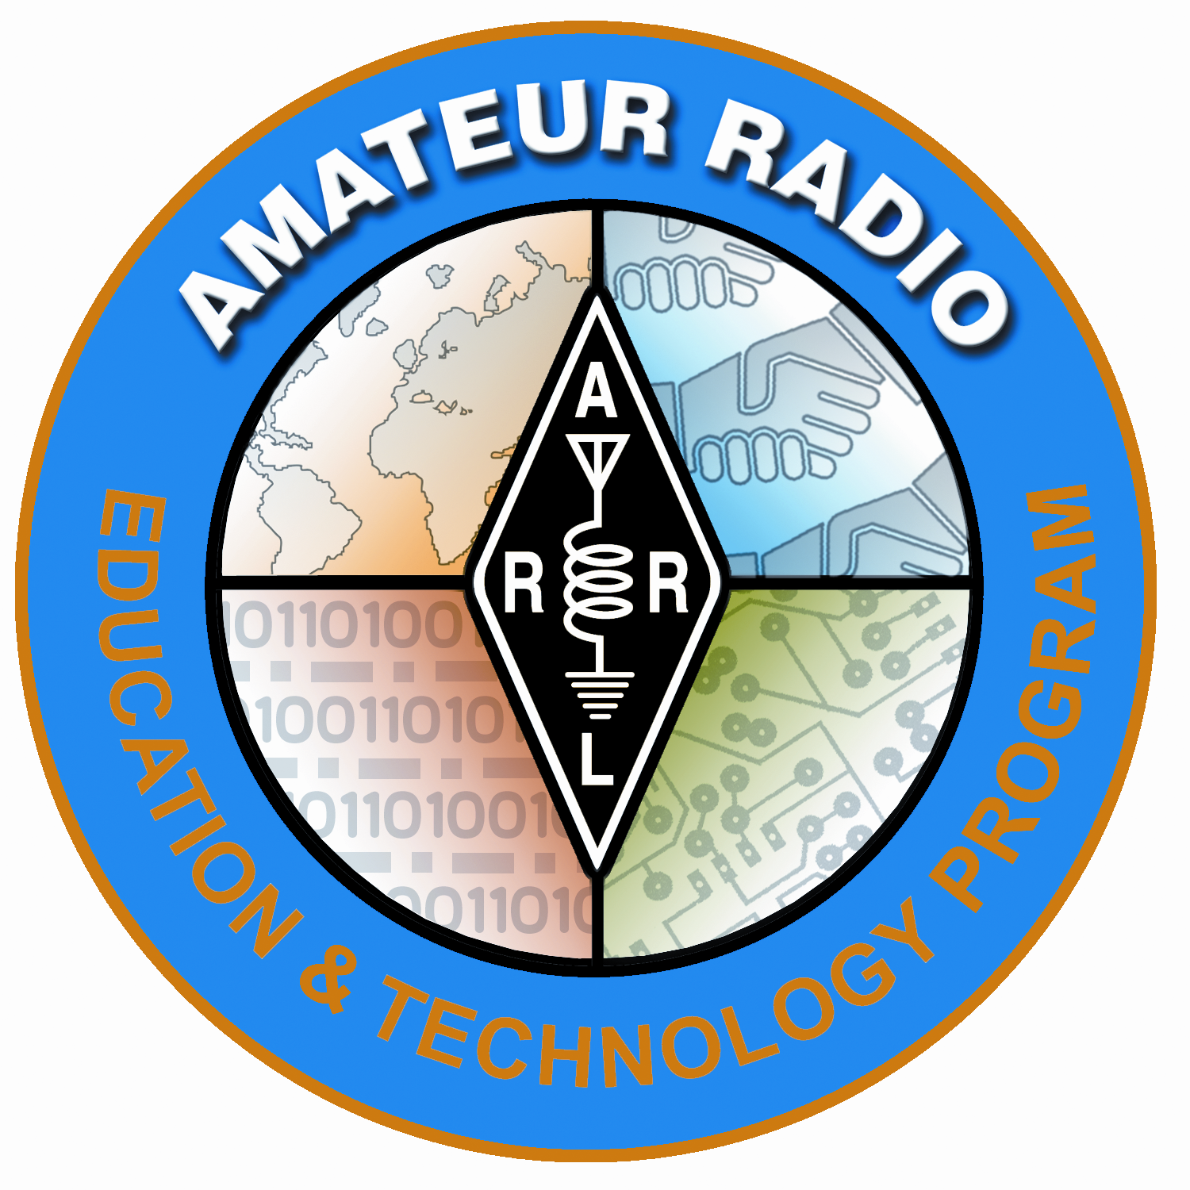
Lesson Plan Prepared for
ARRL Education & Technology Program
Author(s): Nathan McCray | Date: 03/20/2013
Title of Lesson: Transistors | Grade Level: 6 – 12

Core Components

Subject, Content Area or Topic:

Physics, Electronics, Science, Math

National/State Standards: Physics, Electronics, Science, Math

Common Core Standards: (Assign as needed based on your state requirements)

http://www.corestandards.org/

Vocabulary: (Teacher add as needed based on your curriculum and learning requirements)

Learning Objectives (What will the students learn and/or demonstrate?)

The objective of this activity is for the students to explore transistors.

Materials/Resources

Bread board (Prototyping board)
9V Battery
LED
Transistor
Wire leads
Resistor
Volt/Ohm Meter

Safety (if applicable) NA
Review general electrical safety procedures when handling electronic components.

Prerequisite Understanding:
- Basic Electricity
- Current
- I_{E} = I_{B} + I_{C}

Process Components
Anticipatory Set:
(“The Hook” -- something to excite the student about the subject matter)
If you can come up with one, show the students an old transistor radio like the one pictured here (Circa 1956):
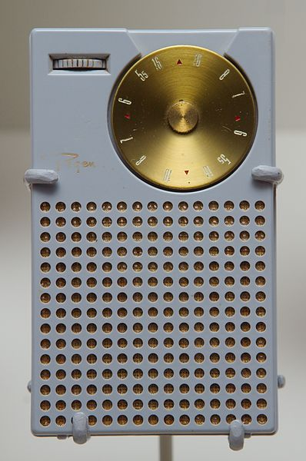

Then show them an old tube radio like this one (Circa 1939):

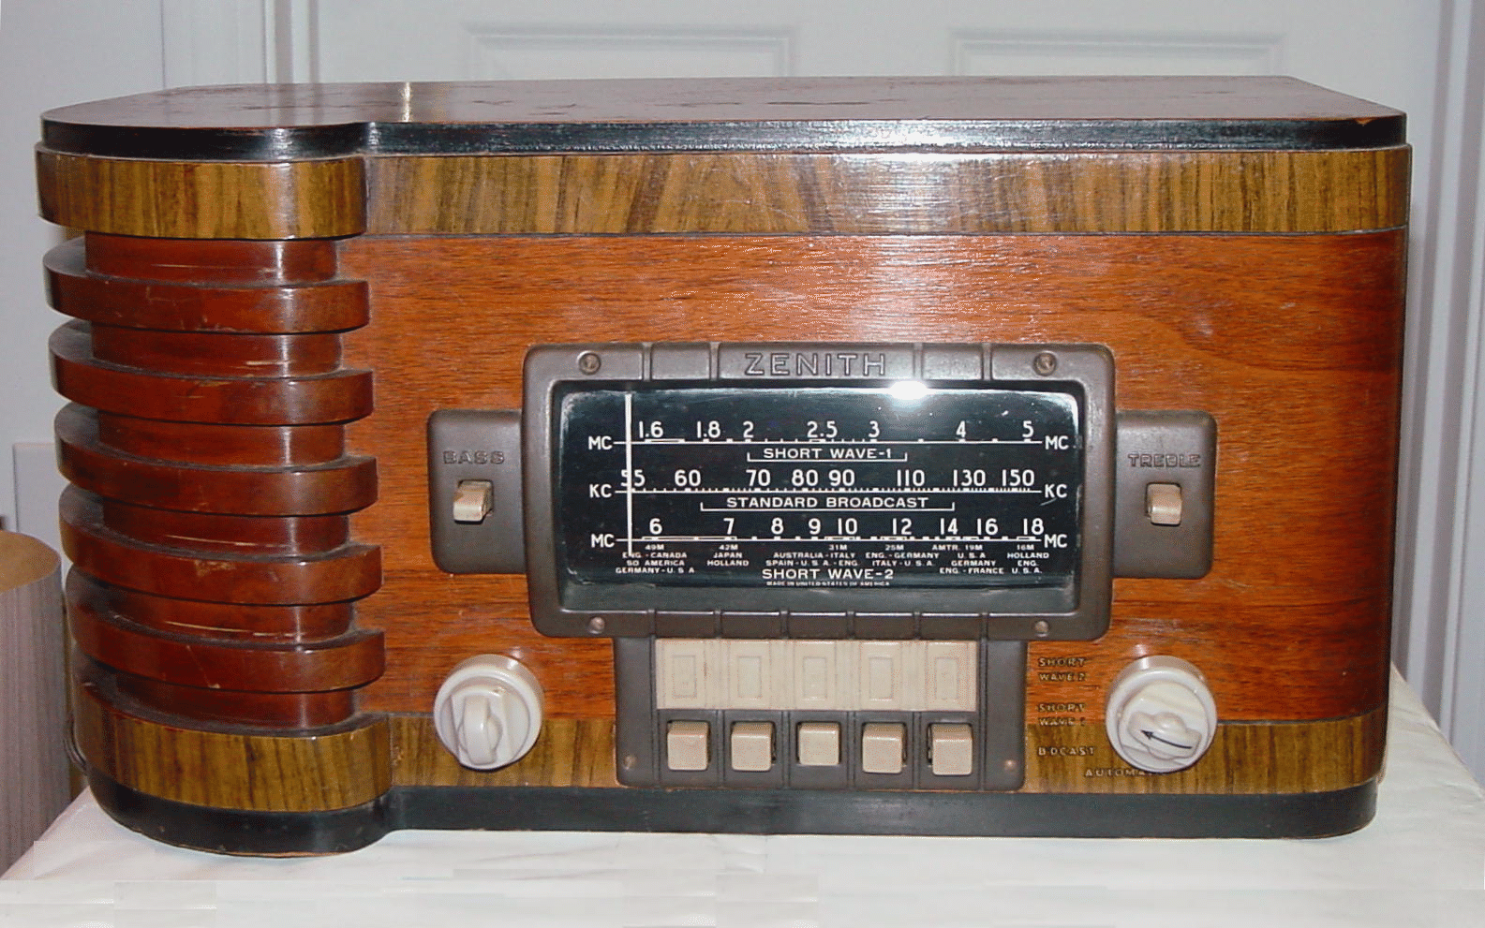

World’s smallest radio:

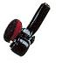

Have your students discuss what changes in technology that leads to light weight, portable radios.

Instructional Input or Procedure (Input, modeling, and checking for understanding)

The transistor main impact on a circuit is its ability to amplify a weak current.

This first demonstration will show your students a weak current that they can easily recognize.

Steps:

Using your butter or proto board build the circuit as shown.

- Connect a circuit using wire, a 9-V battery, an LED, a resistor, and an ammeter to measure current.
- Have your students connect the leads together (This should cause the LED to light brightly
- Next have your students hold the leads in their hands
  - This will produce a small current and the LED should not light.
  - NOTE! Caution! Remind your student that they are using very small currents in the circuit so they are safe. However, also remind them not to use higher currents with this experiment! Safety first!

Guided Practice
- Write an essay describing the electronic device that has had the greatest influence on your life.

Independent Practice
- Offer a research project on the types and sizes of modern transistors. Ask how they are applied to devices and how they work. .

Assessment/Closure

Assessment (Pre, post etc…)
Review how a transistors works. On the way out of class, give your students 3 questions about transistors that should be able to answer from the lesson. Review their answers and assess the effectiveness of your instruction.

Enrichment: As teacher sees fit. Here are some ideas:
- For elementary and junior high students the following activity could engage the entire school. Have a “Transistor Free Day.” Staff and students would have to give up all (or most) of their electronics devices for that day. It is important that the whole school does this activity for getting the full effect. Have your students write about how their life had changed during that day.
- For a great class or team project, have your class or teams design, build and test an electronic device that solves a problem. I would assign extra credit for ideas that help our physically disabled.

Resources/References

http://www.arrl.org/files/file/ETP/Basic%20Electronics%20Course.pdf

ARRL Handbook Pages 2.5 – 2.6

Understanding Basic Electronics pages 9.1 – 9.26

http://www.youtube.com/watch?v=ZYH9dGl4gUE

http://www.wikihow.com/Build-a-Capacitor

http://www.absorblearning.com/electronics/demo/units/AEP_07.html

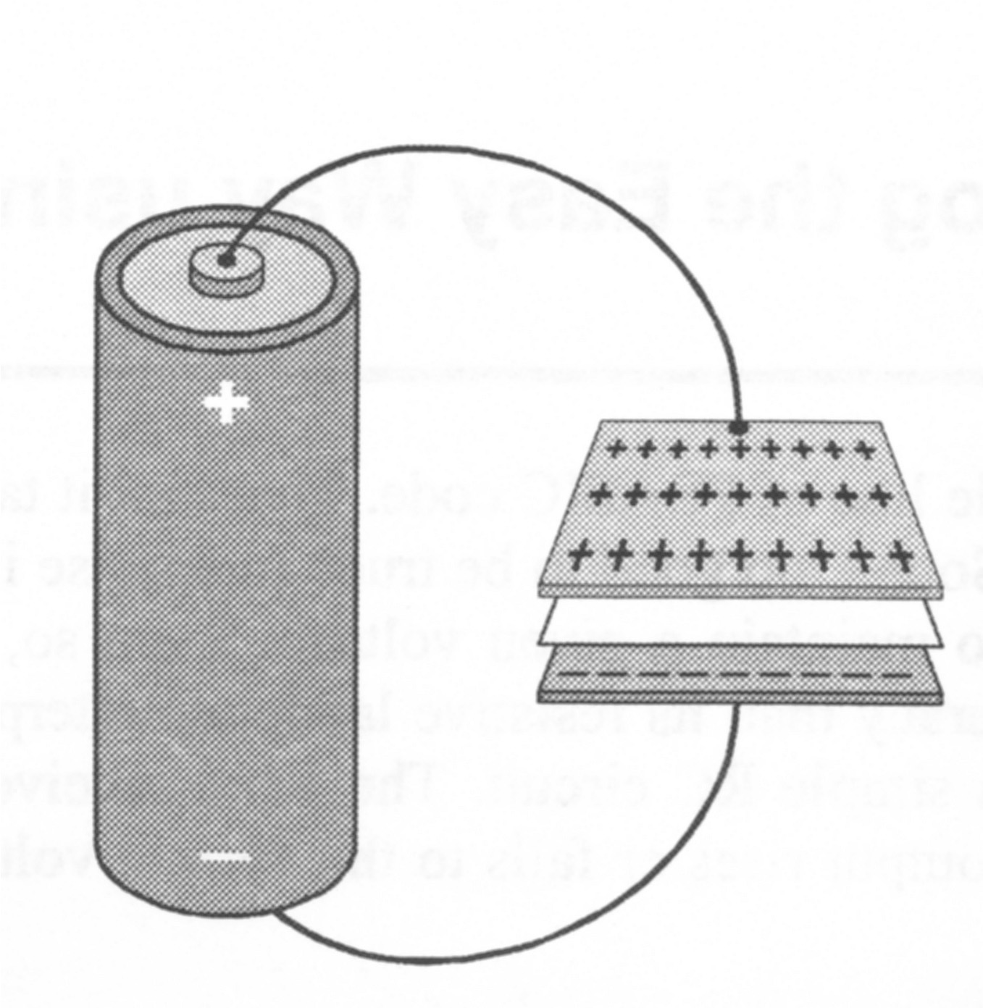

Water Tank Analogy

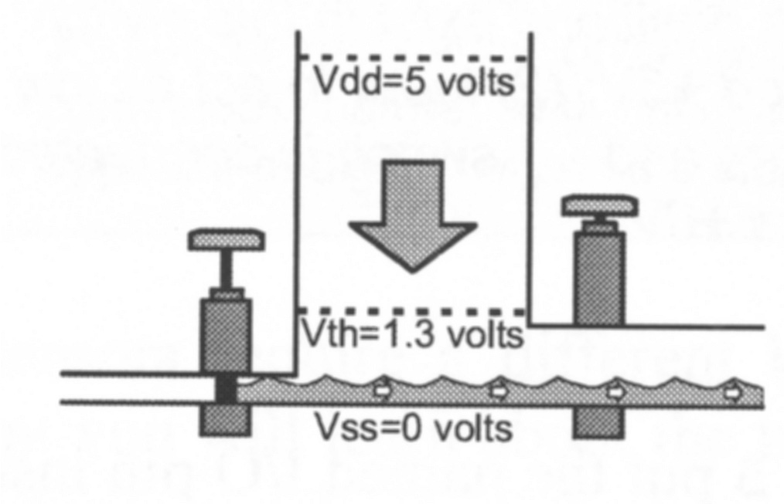
Discharging a Capacitor (Water Tank Analogy)

*Every lesson is different so you may not have to fill in all areas.

Notes:

